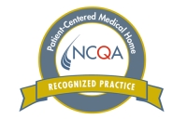

In 2017 Town and Village Pediatrics LLC was recognized as a Patient Centered Medical Home by the National Committee for Quality Assurance. A Medical Home is not a place, it is the way care is provided to children, youth and their families. A Medical Home is the kind of care we all want and deserve. Our goal is to have a trusting partnership between a child/youth, their family, and the primary care pediatric team who oversees the child/youth’s health and well-being.